Callback as Async work:

Example 02 with example 1 functions excluding callbacks before

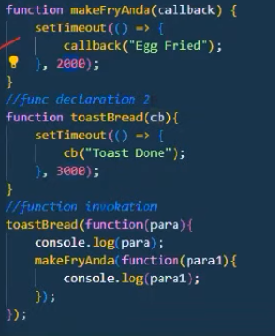

Promise example :

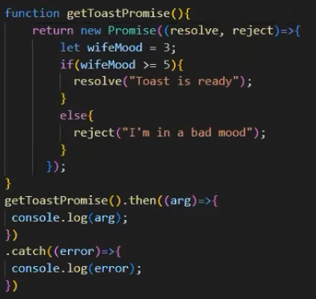

Promise example 3:

Async await promise example :

